|  |
| --- |
| IADE |
| Singing Sands |
| Production Plan  Version 1.0 |

Vasco Correia, 50039633

Maria Brovkina

Contents

1. The Project 3

1.1. Desktop Game 3

1.2. Media notes 3

1.3. Companion App 4

1.4. Design 5

2. The Plot 6

3. The Team 7

4. Initial Planning 8

5. Backlogs 9

5.1. Main Game 9

5.2. Companion App 10

5.3. Server 10

6. Sprints 11

6.1. Sprint 1 11

6.1.1. Objectives 12

6.1.2. Backlogs 12

6.1.3. Sprint 12

6.1.4. Analysis 12

6.1.5. Tasks Review 12

7. Tools 13

7.1. One Drive Structure 13

7.2. ClickUp Structure 14

# The Project

Singing Sands is a fighting game focused on executing combos and the use of abilities in order to defeat the enemy, with the companion app providing creative possibilities for the players, such as drawing and customizing the runes used to enhance the performance of their character.

## Desktop Game

The main game is a fighting arena for Windows PC. It has two game modes: Solo play and local multiplayer.

In the **Solo mode**, the objective of the player is to survive as long as possible, fighting the waves of enemy creatures controlled by the computer (AI). There are 6 starting waves with increasing level of difficulty (health points, attack damage and movement speed of the enemies being boosted) and the number of enemies, 6th being the hardest one. After that, the difficulty will stay at the level of wave 6, and the players will have to endure as many waves as possible. Solo mode is fast-paced, so after each wave the players will be able to replenish some part of their health and rest their hands. Besides having fun, the purpose of this mode is to obtain special runes. There is a 100% chance to get a rune upon finishing the 6th wave and a 20% chance to obtain it from executing a long uninterrupted combo.

The **Local multiplayer** is centered on the fight between two players, controlled on the same machine with the keyboard or joysticks. The players will be able to choose one of the two characters available in the game with their own special abilities and attributes. There are three rounds in a match, the victory is achieved by winning at least 2 rounds out of 3. Players are also offered to equip the runes before the battle begins, that would enhance their experience.

## Media notes

#### Art

The graphics used in the main game is 2D, simplistic and fluid. The sprites of the characters and the enemies are the only elements that contain a lot of details, while the background and the environment overall is done in a way that generally conveys the significance, similar to the example below.

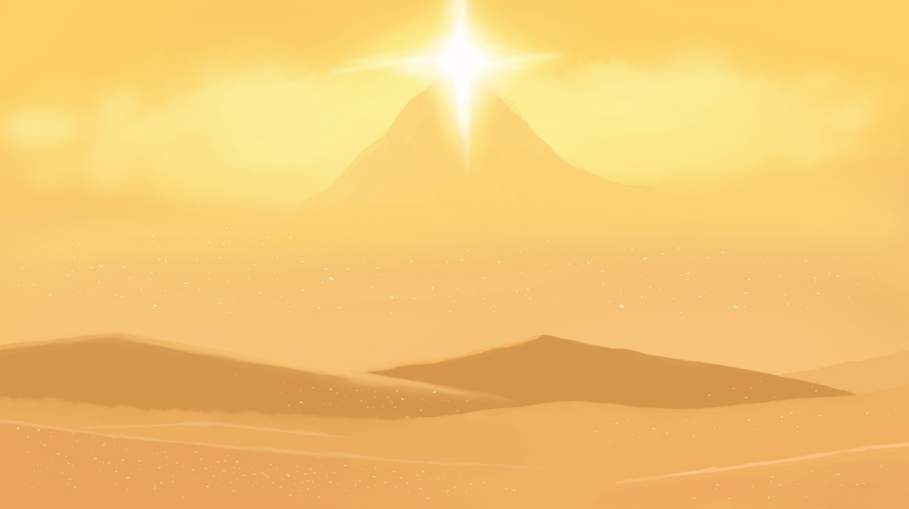Reference art taken from the project ”Journey”

#### Audio

The music and the sound effects are energetic, not very sharp to hear, and with the patterns of modernity. With these requirements, the team believes to achieve the attraction effect and engagement to play.

## Companion App

The companion app for Android is the place where the players are able to see the history of their past battles, manage their account settings, browse the collection of their runes and create new ones by drawing them in the graphical editor and customizing their attributes. It is not mandatory for the main game; however, it will extend the overall experience and make it possible to customize the battle flow.

The use of the companion app is only possible for the players already registered in the main game.

The core feature of the app is the creation of the runes. The players can draw the ornament of the rune they want and in the next menu set certain attributes they want to be powered by this rune. For the sake of the good balance, the attribute that was powered will, at the same time, decrease the other attribute. For example, an ability power boost will worsen the performance of the heavy attack of the character.

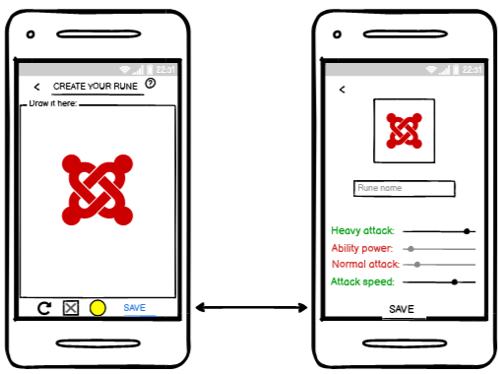

SS Companion App blueprint: Customization page

The runes collection features two inventories with runes. First one is for the runes created by the players and the other one is for the runes obtained in Solo mode. The latter provides players with the ability to sacrifice 4 and more runes to unlock na extra slot for the custom-made runes inventory as it is initially limited to only 1 rune.

## Design

The app is dark-themed, with little art applied only under the menu buttons to picture the text above. The app background is expected to have a dark texture or art similar to the examples below:

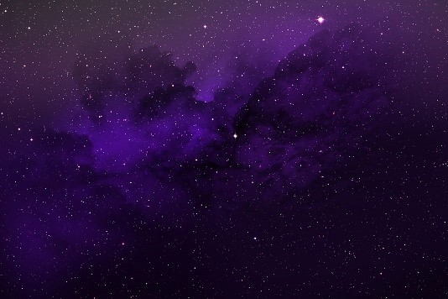 

Reference images taken from another project

The buttons will be highlighted by half-transparent color overlays with the text glowing when pressed.

# The Plot

There has once been a true Heaven on Earth. Good Gods and creatures have given people a good life and prosperity and made everyone equal. However, as the humanity has been slowly evolving, the darkness among their nature has awoken the Evil Gods who, summoned by the wars and competition between people have crawled out of the underworld and decided to take control over divided humans.

In the desert of Eolian the lands have been corrupted by the God of Chaos. The sacred sands of the desert now imbued with the corruption of the God formed artifacts that started being highly sought by all creatures of the world.

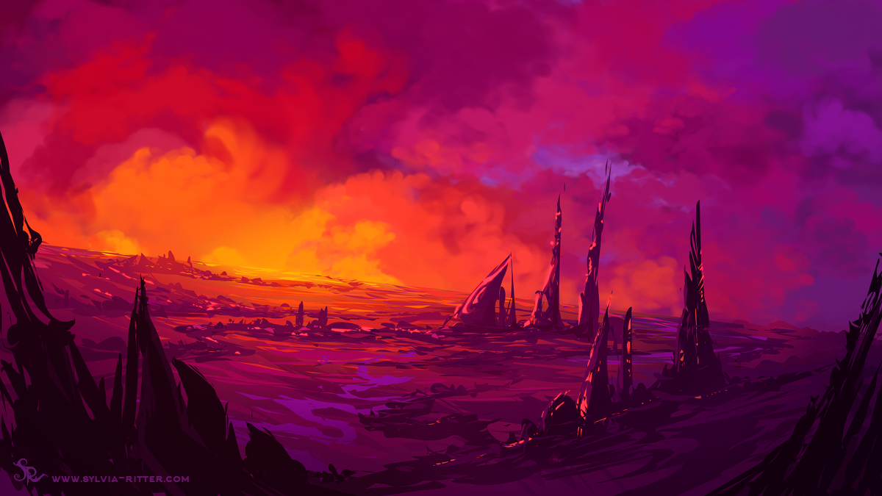Reference image taken from deviantart.com

Motivated by greed and power the chaotic spirits started trying to accumulate as much of the artifacts as possible creating an imbalance in the area and threatening nearby settlements.   
In order to fix the chaos, the guardians of the desert, the good spirits of the warriors once roamed this region, were forced to take action. They started having to fight the bad creatures in order to use or destroy the artifacts.

The two heroes then went against each other. One of them being the son of the Chaos God himself - Kek, and the other – the son of the good spirit of the Desert, Akil. Both youths are the demigods with their abilities equally powerful. It will take one extra effort to beat one another in this tied confrontation.

Reference images taken from deviantart.com

# The Team

The team consists of two students of Games and Apps Development course at UE IADE: Mariya Brovkina and Vasco Correia. This section contains a short information about each one of the members.

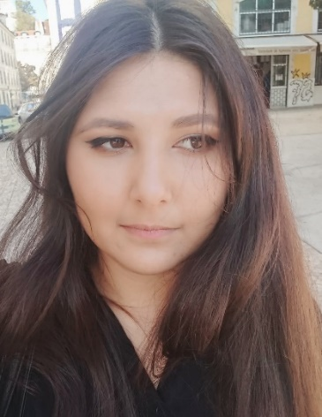***Mariya Brovkina, 23 y.o.***

Originally from Uzbekistan, I have initially enrolled in the course of Philology and Languages in Latvia at the age of 18, later moved to Spain for internship and at the age of 21 has quit the degree to start learning Game Development at IADE in Lisbon. As the majority of the students of our course, I enjoy playing games of various genres. Among my interests there are: languages, programming, astronomy, art, travelling and general science.

***Vasco Correia, 23 y.o.***

Born and raised in Lisbon, Portugal, started studying Electrical, Communications and computer engineering. Since 4 years old I always had a passion for videogames and games in general. The challenge, progression, competitiveness, and problem solving they provide always captivated me, leading me to the decision of enrolling in Games Development in IADE.

Now, tackling the logic of implementing and creating a simulated environment is my favorite part of the process. Among my interests are: Physics, programming, astronomy, and dialogues.

# Initial Planning

The development is divided into 13 sprints, each one lasting for 7 days.

The first sprint has begun on 13th of November 2020. Below is the table with the sprints report as well as the start and the end date for each.

Sprints

There are also three major milestones throughout the whole course of development:

* The documentation and ideas presentation (on 18th of November);
* The prototype of the game (8th of January);
* The vertical slice.

# Backlogs

## Main Game

Game backlog

## Companion App

Companion App backlog

## Server

Server backlog

# Sprints

## Sprint 1

documentation task subtasks

first sprint board

### Objectives

Finishing completely all documentation: spec sheet, production plan, app blueprints, game design document. Start developing basic player movement.

### Backlogs

All tasks planned for the first sprint were concluded.

### Sprint

All companion app blueprints, and spec sheet were done by Maria, Both Vasco And Maria worked on every other documentation.

### Analysis

Discussions and brainstorming to construct all game design and companion app between the team and the professors were the main methods used to complete this sprint.

For the rest of the sprint we will begin implementing basic player movement in Unity.

### Tasks Review

All tasks were completed without any change on the backlogs. So far, the project is advancing according to plan.

# Tools

## One Drive Structure

One Drive is being used to organize the folders/files of the project. The main folder has 4 subfolders: App, Assets, GDD, and the Spec Sheet.

Main Folder

The App folder has all files related to the Companion App.

App folder

The Assets folder has all sprites, artwork, reference images, audio related files.

Assets folder

The GDD folder has all the versions of the Game Design Document.

GDD folder

The Spec Sheet folder the spec sheet.

## ClickUp Structure

On the project click up site there are 2 folders called Sprints and Backlogs. Inside the backlog folder we find game backlog, the app backlog, and the server backlog.

On the sprints folder we find the first two sprints and the bugs lists. The first sprint list initiated in 13/11/2020 has the tasks to do and the tasks in progress with its sub tasks completed.

For the rest of the sprint we will begin implementing basic player movement in Unity.